Topic: Brain Tumor Detection using python, sklearn and OpenCV

Name: Dharan Thaker(40194790) and Arjun Anghan ()

github:-

Abstract:

Image processing has become a critical field in the detection and diagnosis of brain tumors. One of the most challenging tasks in this area is the accurate and efficient classification of digital images of the brain to identify abnormalities. In recent years, machine learning algorithms have emerged as an effective tool for this task, with logistic regression and support vector classifier being two popular methods used in the detection of brain tumors[1]. Logistic regression is a statistical method that is used to analyze relationships between variables. In the context of image processing, logistic regression can be used to classify digital images of the brain into two categories: normal and abnormal. Logistic regression can also be used to extract features from images that can be used to identify abnormalities. Support vector classifier, on the other hand, is a machine learning algorithm that can be used for both classification and regression. In the context of brain tumor detection, support vector classifier can be used to classify digital images of the brain into two or more categories based on their features. In this study, we performed a comparative analysis of logistic regression and support vector classifier for brain tumor detection using image processing. We applied both algorithms to a dataset of digital brain images and evaluated their performance using various evaluation metrics, including accuracy, precision, recall, and F1 score.

index terms:- Logistic regression, Support Vector Classifier, image classification, accuracy, precision, recall, F1 score

1. Introduction:

A brain tumor is an abnormal growth or mass of cells in or around the brain. Brain tumors can be either malignant or benign, and they can grow at different rates. While only about one-third of brain tumors are cancerous[2], both cancerous and noncancerous brain tumors can impact brain function and overall health if they grow large enough to press on surrounding nerves, blood vessels, and tissue.

In recent years, artificial intelligence-assisted automatic or semi-automatic detection and segmentation methods have become increasingly important in medical diagnosis for brain tumor detection and segmentation. These methods are critical for medical practitioners to validate the limits and regions of the brain tumor, determine its exact location and affected areas, and plan appropriate treatment such as chemotherapy, radiotherapy, or brain surgery.

In the context of image classification, supervised learning has been used to develop models that can accurately classify images into different categories or classes. Supervised learning is a type of machine learning that involves training a model on labelled data. In supervised learning, the model learns to make predictions by analysing a dataset that contains both input features and their corresponding output labels. The goal of supervised learning is to train a model that can accurately predict the output label for new, unseen input data. Supervised learning has shown great promise in image classification and brain tumor detection, as it allows models to learn from labelled examples to accurately identify patterns in the data that are indicative of specific conditions or features.

These models are trained on a dataset of labelled images that represent each class, allowing the model to learn the features that distinguish between the different classes. In the case of brain tumor detection, supervised learning has been used to develop models that can accurately detect and segment brain tumors from medical images. These models are trained on a dataset of labeled brain images that have been classified as normal or abnormal, allowing the model to learn the patterns that are indicative of a brain tumor.

The first step in making a model to classify brain tumor images is to obtain a dataset that contains images of brain tumors and corresponding labels indicating whether a tumor is present in each image. Once you have obtained a dataset, the next step is to pre-process the images to remove any noise or artifacts that could interfere with the model's ability to accurately classify the images. This might involve techniques such as image filtering or image enhancement to improve the quality of the images.

After pre-processing the images, the next step is to scale the dataset to ensure that all features are on the same scale. This is important because many machine learning algorithms are sensitive to the scale of the features and may perform poorly if features are not normalized. Once the dataset has been scaled, it can be split into a training set and a test set.

The next step is to perform feature selection to identify the most important features that are predictive of whether a brain tumor is present in an image. This involves technique called as principal component analysis to identify the most important features. Once the features have been selected, the next step is to train a machine learning model, such as a logistic regression or support vector classifier, on the training set. Finally, the model can be evaluated on the test set to determine its performance in classifying brain tumor images.

The models that were taken into consideration were Logistic Regression and Support Vector Classifiers (SVC). Once trained, the algorithms can be applied to new, unlabelled images to predict the likelihood that they contain a brain tumor. Logistic regression works by modelling the probability of a brain image being abnormal using a logistic function that maps the image features to the probability of the image being abnormal. On the other hand, support vector classifiers separate the normal and abnormal brain images by constructing a hyperplane that maximally separates the two classes. This hyperplane is determined by the support vectors, which are the images closest to the decision boundary. Both algorithms can be fine-tuned using a range of parameters to improve their accuracy and reduce the risk of overfitting.

In Summary ,this paper identifies the most suited model to the problem of brain tumor classification of images. The subsequent sections in the paper aims to provide the in depth information about other related works, the dataset used, the proposed methodology, the results acquired and an interpretation of these in the conclusion.

1. Related Work

When developing a machine learning-based intelligent system for brain tumor classification, researchers typically begin by segmenting brain tumors through the use of different methods, followed by classification[3]. Although this approach enhances accuracy, it can be time-consuming and requires an additional step prior to network training. Despite this, several researchers have employed CNNs to directly classify brain tumors, bypassing the need for segmentation.

Justin et al. [4] utilized three classifiers - random forest (RF), a fully connected neural network (FCNN), and a CNN - in order to enhance classification accuracy. The CNN demonstrated the highest accuracy rate at 90.26%. Meanwhile, Tahir et al. [3] examined several preprocessing techniques to improve classification results. They experimented with three techniques: noise reduction, contrast enhancement, and edge detection, testing various combinations on different test sets. Their findings suggest that utilizing multiple techniques is more advantageous than relying on a single one. Tahir et al. employed the Figshare dataset and tested the SVM classifier on it, achieving an 86% accuracy rate. Ismael et al. [5] proposed a new approach to brain tumor classification by combining statistical features with neural networks. They utilized MR images to extract statistical features for classification and incorporated 2D discrete wavelet transforms (DWT) and Gabor filters for feature selection. The segmented MR images were fed into their algorithm, which resulted in an average accuracy of 91.9%. By utilizing the DWT and Gabor filters, they were able to effectively reduce the dimensionality of the features, while still preserving the relevant information. This method proved to be successful in improving the classification accuracy of brain tumors.

In [6], a project aimed to classify multi-grade brain tumors is described. The method uses a pre-trained CNN model in combination with segmented images. To handle class imbalance and improve accuracy, data augmentation is performed using various techniques. The model is validated on three different datasets, and the results presented are compelling.

In [7], Nayoman et al. investigated the use of CNNs for brain tumor classification. They constructed seven different neural networks and found that a lightweight model performed best. Without any prior segmentation, this simple model achieved a test accuracy of 84.19%.

Guo et al. [8] proposed a classifier for Alzheimer's disease using graph convolutional neural networks (GCNNs). The ADNI dataset was used to classify Alzheimer's disease into 2 and 3 categories. The proposed graph nets achieved an accuracy of 93% for 2-class classification compared to 95% for ResNet architecture and 69% for the SVM classifier. In the three-class classification, the proposed graph CNN achieved 77%, ResNet achieved 65%, and SVM achieved 57%.

GAN-based networks have become increasingly popular for generating synthetic medical images due to their remarkable performance. Liu et al. [9] have proposed a variation of Cycle GAN that uses a domain control module (DCM) and a Pseudo Cycle Consistent module (PCCM) to generate Computed Tomography (CT) images. This approach has shown promising results in producing high-quality synthetic CT images that are useful for a variety of medical applications. The DCM allows the user to control the appearance of the generated images, while the PCCM helps to ensure consistency between the generated images and the real ones.

The utilization of GANs has garnered significant interest from researchers, and these models are now being extensively used in various medical imaging domains. Researchers are trying to enhance their results by utilizing more complex and deeper architectures. Although GAN-based studies have different approaches, they all use random Gaussian noise as the input to the generator of the GAN. However, in the field of generative medical imaging, exploring the manipulation of the input noise of GANs is still largely unexplored.

[A] Dataset

The dataset is taken from Kaggle is of contains 3264 images from 4 different classes of tumor class namely glioma_tumor, meningioma_tumor, no_tumor, pituitary_tumor, which has 100 files, 115 files, 105 files and 74 files respectively. Since the images did not have uniform dimensions, so they must be pre processed before hand in order to be applied to the model.

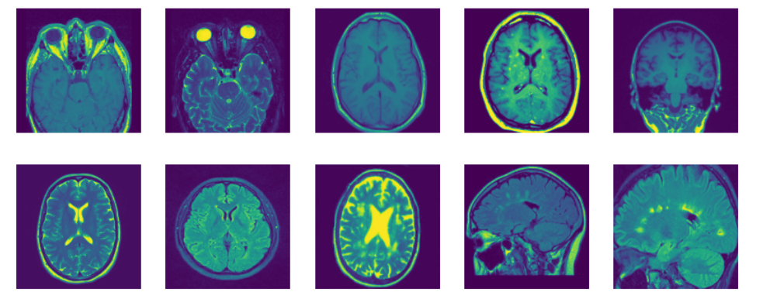

Fig 1. sample images of no tumor and pituitary tumor

In summary, the paper

In summary, the process of making a model to classify brain tumor images involves obtaining a dataset, preprocessing the images, scaling the dataset, performing feature selection, training a machine learning model, and evaluating the model's performance. This process can be time-consuming and requires careful attention to detail, but it has the potential to greatly improve the accuracy and speed of brain tumor detection and diagnosis, ultimately improving patient outcomes.

Top of Form

**[Not included in introduction]**

**The use of logistic regression and support vector classifiers has significantly improved the accuracy of brain tumor detection and segmentation, aiding medical professionals in the diagnosis and treatment of brain tumors. These machine learning algorithms have the capability to analyze large sets of data and extract patterns that can be used to identify abnormalities in brain images.**

**Logistic regression and support vector classifiers are both supervised learning algorithms that have shown great promise in the detection and segmentation of brain tumors. These algorithms work by identifying patterns or features in labeled datasets that are used to classify new, unlabeled data. In the case of brain tumor detection and segmentation, the algorithms are trained on a dataset of brain images that have been labeled as either normal or abnormal. The algorithms analyze the labeled data to identify patterns that distinguish between normal and abnormal brain images. The identified patterns can include variations in texture, shape, and intensity of image pixels.**

1)References: <https://www.sciencedirect.com/topics/computer-science/tumor-detection>

2) <https://my.clevelandclinic.org/health/diseases/6149-brain-cancer-brain-tumor>

3) Tahir B., Iqbal S., Usman Ghani Khan M., Saba T., Mehmood Z., Anjum A., Mahmood T. Feature enhancement framework for brain tumor segmentation and classification. *Microsc. Res. Tech.*2019;82:803–811. doi: 10.1002/jemt.23224.

4) Paul J.S., Plassard A.J., Landman B.A., Fabbri D. Deep Learning for Brain Tumor Classification. *Proc. SPIE Spie Med. Imaging .*2017;10137:1–16.

5) Ismael M.R., Abdel-Qader I. Brain Tumor Classification via Statistical Features and Back-Propagation Neural Network; Proceedings of the 2018 IEEE International Conference on Electro/Information Technology (EIT); Rochester, MI, USA. 3–5 May 2018; Piscataway, NJ, USA: IEEE; 2018. pp. 252–257.

6) Sajjad M., Khan S., Muhammad K., Wu W., Ullah A., Baik S.W. Multi-grade brain tumor classification using deep CNN with extensive data augmentation. *J. Comput. Sci.*2019;30:174–182. doi: 10.1016/j.jocs.2018.12.003.

7) Abiwinanda N., Hanif M., Hesaputra S.T., Handayani A., Mengko T.R. *World Congress on Medical Physics and Biomedical Engineering 2018.* Springer; Singapore: 2019. Brain Tumor Classification Using Convolutional Neural Network; pp. 183–189.

8) Guo J., Qiu W., Li X., Zhao X., Guo N., Li Q. Predicting Alzheimer’s Disease by Hierarchical Graph Convolution from Positron Emission Tomography Imaging; Proceedings of the 2019 IEEE International Conference on Big Data (Big Data); Los Angeles, CA, USA. 9–12 December 2019; Piscataway, NJ, USA: IEEE; 2019. pp. 5359–5363.

9) Liu Y., Chen A., Shi H., Huang S., Zheng W., Liu Z., Zhang Q., Yang X. CT synthesis from MRI using multi-cycle GAN for head-and-neck radiation therapy. *Comput. Med. Imaging Graph.*2021;91:101953. doi: 10.1016/j.compmedimag.2021.101953.